Matt Ryan
2/17/19
Milestone 4: Enhancement 3

As with the previous two enhancements, this artifact is the CS340 Final Project; I selected this project at the suggestion of the ePortfolio Selection and Refinement Plan rubric. My choice for this enhancement was to “add more advanced concepts of MongoDB”. (Chodorow & Dirolf, MongoDB: the definitive guide, 2015) I had no specific instruction as to what concepts to add, so I researched, selected, and implemented “replication”. The textbook from CS340 defines replication as a way of keeping identical copies of your data on multiple servers. I would also like to implement some security features in the final version if I face no complications implementing replication and time permits.
As I worked on this enhancement I hit an obstacle as I discovered that my initial attempt at implementing replication would require multiple devices I could use for testing. As such, the rest of this document uses the simpler ReplSetTest data structure, while my draft for my initial, untested attempt can be found in the Replication Setup Commands 2 document on the github repository with the rest of the artifact.
In the first terminal, I set up the replica set and initialize it. The below image is the result.
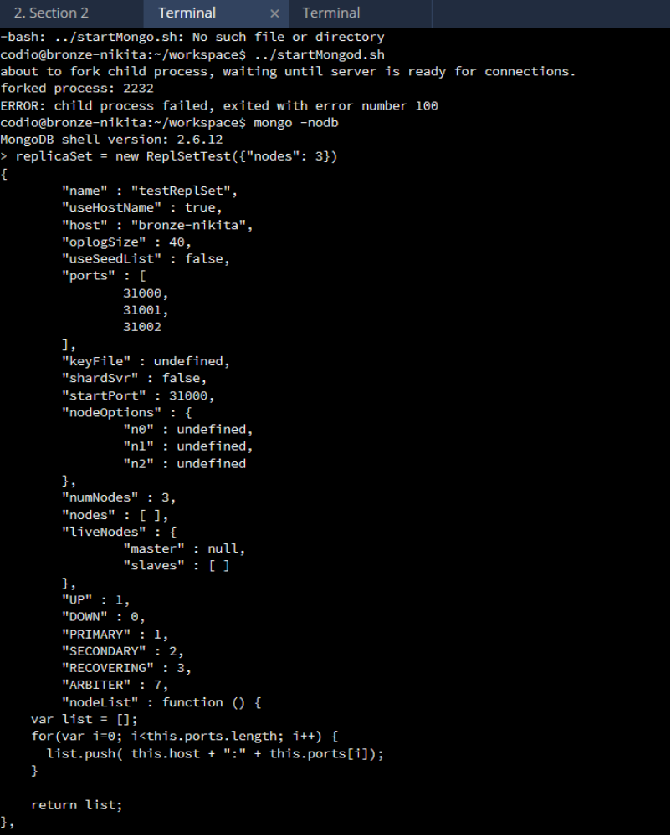

After the results of that image, I also use the following commands...

replicaSet.startSet()
replicaSet.initialize()

The terminal begins spewing output after this, so a separate terminal will be used for the individual hosts. The following image shows me connecting to and testing the primary. The result of isMaster() confirms that this connection is the primary. The for loop adds documents to the collection for testing purposes. The count statement immediately after shows that the population of the collection was successful.
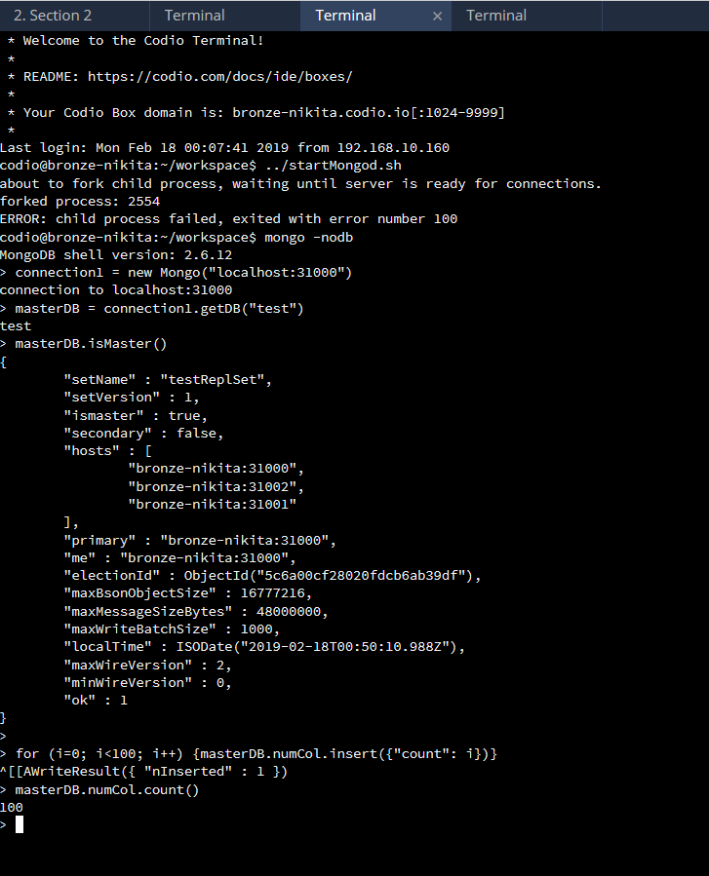

Now I will test the limits of one of the secondaries. As you can see from the result of the first findOne(), secondaries cannot be read from by default (to prevent reading of out-of-date data). The setSlaveOk() function removes this safeguard and as a result, the next findOne() returns a value. Lastly, we will attempt to insert a new document into the secondary; this is not permitted, as secondaries are only modified by the primary updating them. We now that we have a functional replica set, we can remove the test data and import the values from the original project.
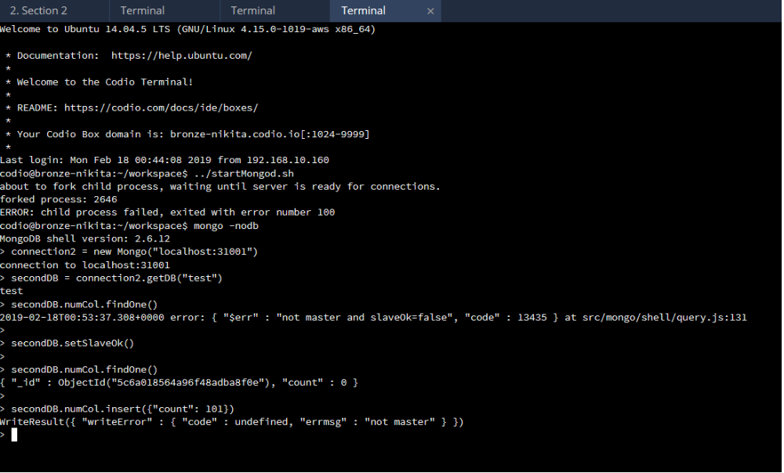
References
Chodorow, K., & Dirolf, M. (2015). MongoDB: The definitive guide. Sebastopol, CA: OReilly.

